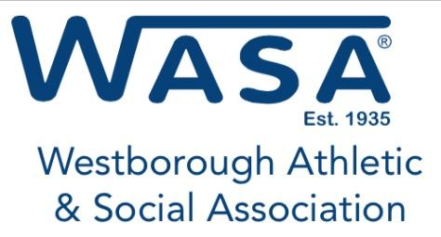
Graduating Senior Scholarship Application
Westborough High School
Assabet Valley Voc.
WASA/Prototype Training System Partnership
Deadline for Filing is April 30, 2024
Application pertains to students attending an accredited two-year or four-year college. Financial award will be paid to the winning candidates upon notification.
Student Information
Full Name: | Email address:
Home Address: | Phone #
Father: | Occupation:
Mother: | Occupation:
Family members attending college next year
(number only):
Expected college expenses
Tuition: $ | Room and Board: $
Books and Lab Fees: $ | Transportation: $
 | Total Expenses: $

Family Gross Income Level | Check appropriate
Below $50,000 | ☐
$50 - $100K | ☐
$100K - $150K | ☐
$150K - $200K | ☐
$200 - $300K | ☐
$300K + | ☐

Have you worked while attending High School? Yes ☐ No ☐
Company Name | Job Description

Explain the type of work experiences:
Please list activities that you have been involved with during High School: Please note: The level refers to the type of activity, was it school sponsored, recreation/AAU/Club/Other Freshman/JV/Varsity – Please denote any special distinctions - Captain, MVP, League All Star.
 |  | Frosh | Soph | Junior | Senior
FALL | Activity
 | Level
 | Distinctions
WINTER | Activity
 | Level
 | Distinctions
SPRING | Activity
 | Level
 | Distinctions
SUMMER | Activity
 | Level
 | Distinctions
National Honor Society member? Yes ☐ No ☐
Student Council member? Yes ☐ No ☐
Please list other scholarships or financial assistance you are receiving including specific dollar amounts:
Name | Amount

Please list any additional factor(s) or financial considerations that will assist the WASA Scholarship Committee in weighing your situation to determine your qualification for this scholarship assistance. Please include all community service work and projects.

** Please remember to include a copy of your current Senior term grades. Your application will not be considered without it. Full transcript required.
Applicant’s signature |  | Date
Father/Guardian signature |  | Date
Mother/Guardian signature |  | Date

BE ASSURED THAT ALL THE ABOVE INFORMATION IS STRICTLY CONFIDENTIAL
Please email or return to below address:
Mhiggins3386@gmail.com
Westborough Athletic and Social Association
P.O. Box 165
Westborough, MA 01581
Attn: Scholarship Committee

